**Manuscript**

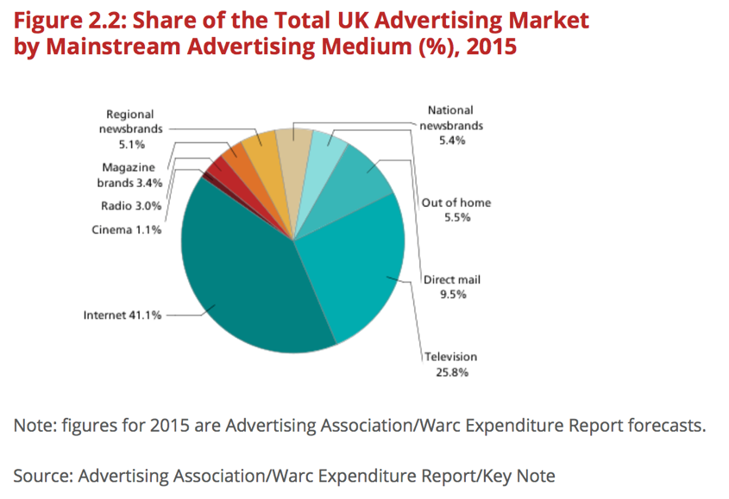

**Figure 1.** Share of the Total UK Advertising Market by Mainstream Advertising Medium (%) (Key Note 2015)

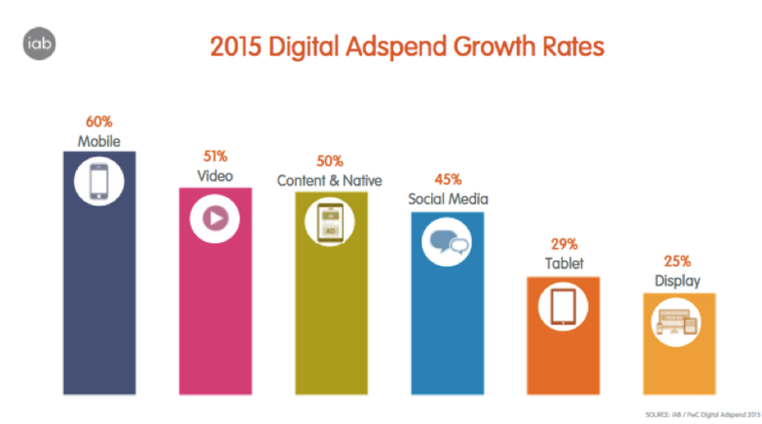

**Figure 2.** Digital Advertising Formats in the UK (IAB 2015)

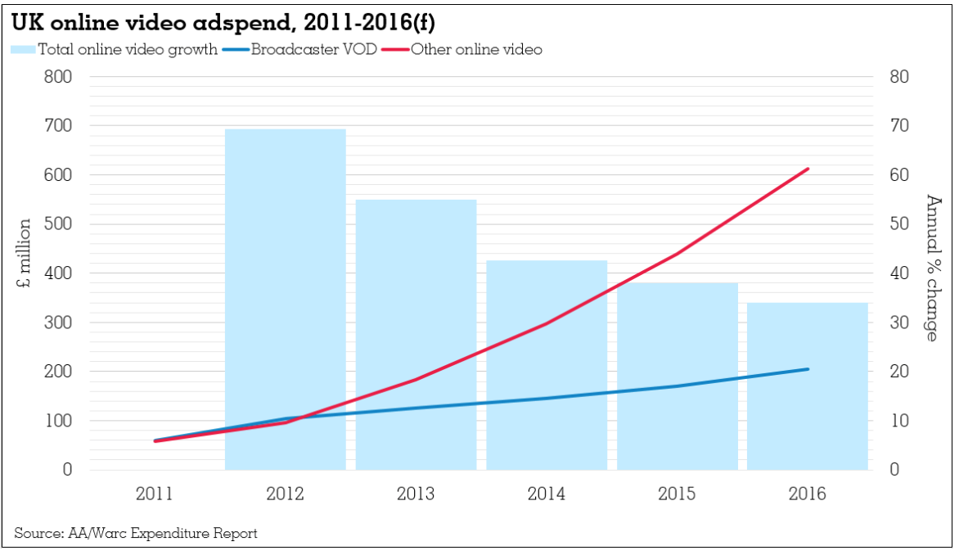

**Figure 3.** UK Online Video adspend (Mcdonald 2015)

**Table 2.11 Consumer Behaviour models (Katz 1960; Fishbein and Ajzen 1975; Krugman 1965)**

|  |  |  |
| --- | --- | --- |
| **Model** | **Strengths** | **Limitations** |
| **ABC Model of Attitudes** | Mainly the findings show the strength with which an attitude is held is often a good predictor of behaviour (Lee and Lee 2011). Therefore, the stronger the attitude the more likely it should affect behaviour. Lee and Lee’s (2011) study on factors influencing intentions to watch OVAs found the more positive an attitude towards an OVA, the more likely an individual would watch it. These findings are very useful in supporting objective 2 and will be tested in the research. | The model provides a basis to forming attitudes, there are levels of commitment to an attitude that lie deeper beyond its purpose (Solomon et al 2013). Difficulties arise when attempting to explore cognitive and behavioural effects of OVAs. Lee and Lee (2011) acknowledge that other behavioural beliefs for watching OVAs did not predict their attitudes towards watching ads. |
| **Theory of Reasoned Action (TRA)**  http://is.theorizeit.org/w/images/6/60/Tra.JPG | TRA assumes that the best predictor of behaviour is intention (Fishbein and Ajzen 1975). When tested on OVAs, a more positive attitude towards the act or behaviour increases behavioural intention, leading to a behavioural action (Lee and Lee 2011). A number of studies have found strong and positive relationships between behavioural intention and actual behaviour because people tend to perform behaviours that they plan to execute (Bagozzi, Baumgartner, and Yi 1992; Choo, Chung, and Pysarchik 2004; Conner and Armitage 1998; Oliver and Bearden 1985; Ryan and Bonfield 1980; Lee et al 2013). The model predicts that behavioural intent is created or caused by two factors: attitudes and subjective norms. | TRA assumes attitudes towards a behaviour is determined by behavioural beliefs, a “person’s beliefs that the behaviour leads to certain outcomes and his evaluations of these outcomes” (Lee and Lee 2011 p. 620). Fishbein (1980) explicitly acknowledged their model’s limitation concerning the distinction between goal intention and behavioural intention. The model was developed to deal with behaviours, not outcomes or events that result from behaviours (Sheppard et al. 1988). This presents a clear weakness in the model because it doesn’t give explanation about how outcomes are triggered, which must be established in satisfying objective 2. |
| **Involvement Theory** | Involvement is the degree of personal relevance and risk perceived by consumers when making a particular purchase decision (Bauer et al. 2006; Rossiter et al. 1991; Heath 2001).  Involvement theory is useful in understanding the fundamental premise of the decision-making process. The theory can be used to identify two main approaches to consumer decision-making: high and low involvement (Fill 2013). These approaches lead to two uses of marketing communications. The model will be applied in the research testing objective 3, being useful to inform objectives 1 and 2. | The model implies the level of involvement may vary through time as each member of the target market becomes more familiar with the purchase and associated communications (Fill 2013). This is supported by McQuarrie and Munson (1992 p. 108) as “clearly, allegiance to one or another theoretical position is going to have marked effects on how one measures the construct”. A major limitation as the levels of involvement can vary based on the individual. |
| **High Involvement decision-making** |
| **Low Involvement decision-making** |

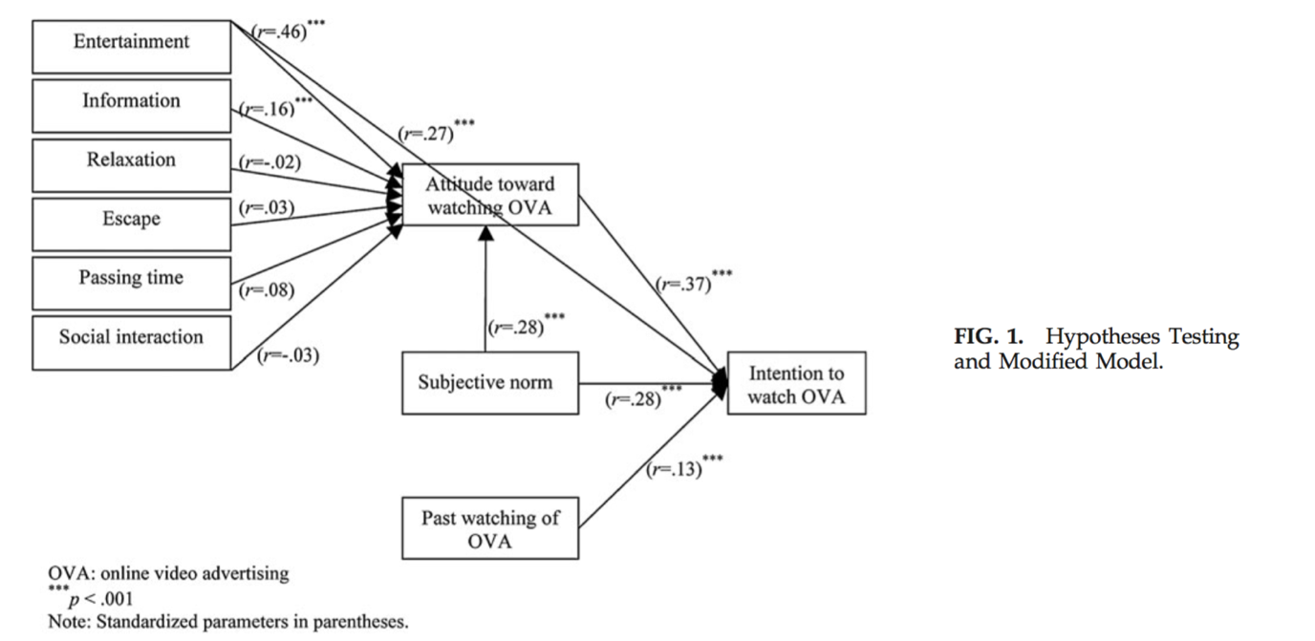

**Figure 4.** Hypothesis model, intentions to watch OVA (Lee and Lee 2011, p. 622)

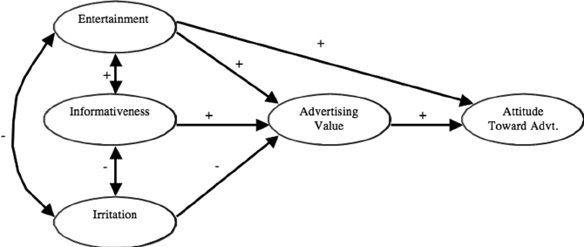

**Figure 5.** Advertising Value Model (Ducoffe 1995; 1996).

|  |  |
| --- | --- |
| **Independent Variables (perceptions towards the advert)** | **Dependent Variables (attitudes)** |
| Informativeness | Did you like the advert? |
| Entertainment | Attitudes towards the product? |
| Irritation | How do you feel about in-stream adverts? |

**Figure 6.** Framework for assessing advertising value (Ducoffe 1996; Logan et al 2012; Goodrich et al. 2015)

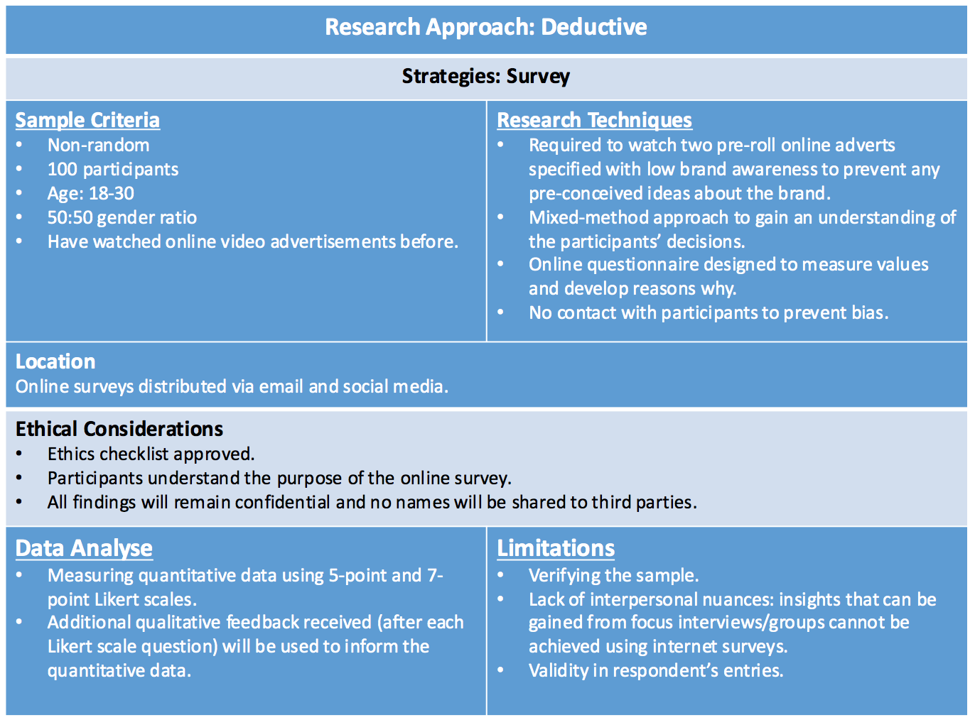

**Figure 7.** Methodology Design (Author: Atkinson 2016)



**Table 3.2** Research Plan

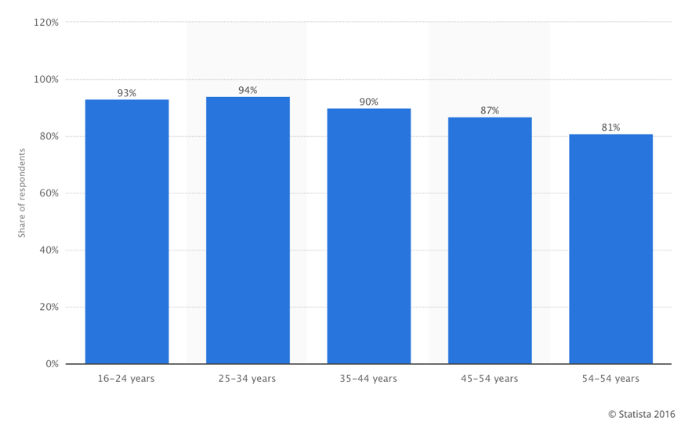

**Figure 8.** Online video viewing penetration among internet users worldwide, by age group. Q1 2016 (Statista 2016)

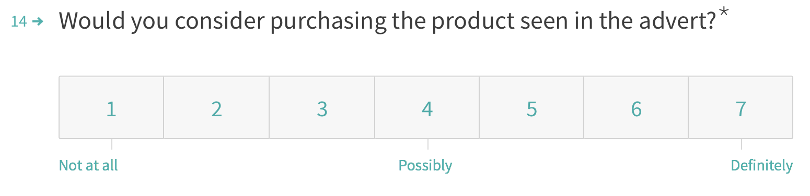

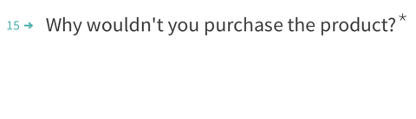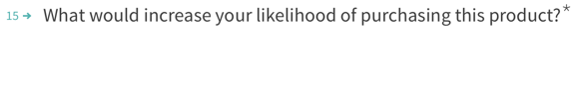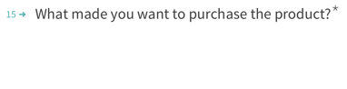

**Figure 9.** Personalised open-ended questions are affected by Likert scale responses.



**Figure 10**. Male (headphones), 30 seconds (SMS by 50 2013).



**Figure 11**. Female (beauty products), 30 seconds (M&C Saatchi 2013)

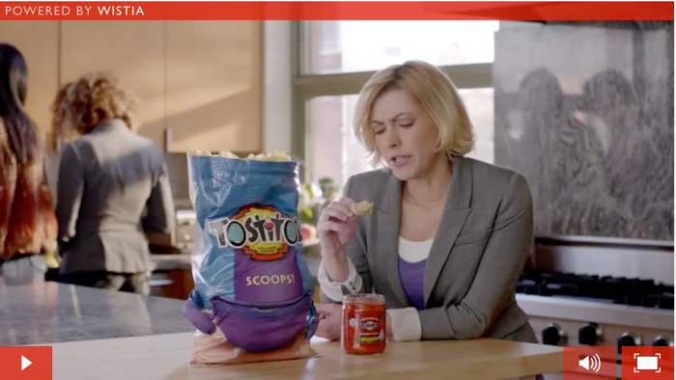

**Figure 12.** Low Involvement ad featuring FMCG product, 30 seconds (LA Egotist 2012).

**1.**

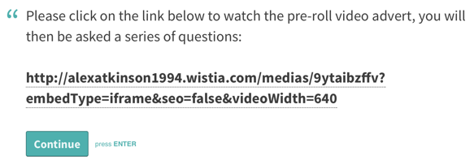

**2.**

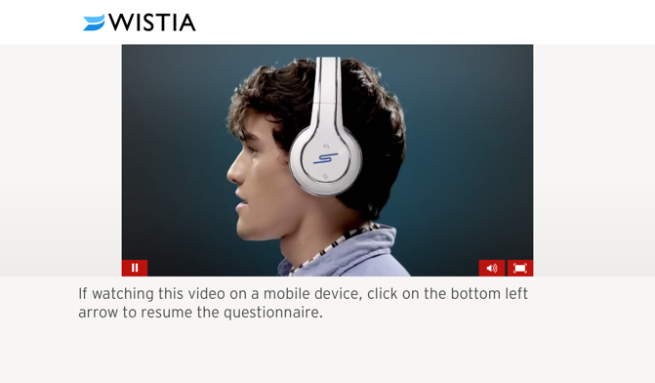

**Figure 13.** By Clicking on the link (1), you are a taken to a microsite where the pre-roll video will auto-play (2) between answering questions.

**Figure 14:** Number of Respondents by Gender. Male (48) & Female (53).

**Figure 15:** Age of Respondents %. 18-21 (41), 22-25 (51), 26-30 (9).

|  |  |  |  |
| --- | --- | --- | --- |
| **Type of Advert** | **Gender** | **Yes** | **No** |
| High Involvement (appendix 31) | M | 14% | 86% |
| High Involvement (appendix 32) | F | 0 | 100% |
| Low Involvement  (appendix 33) | M/F | 9 % | 91% |

**Figure 16.** Brand Awareness test.

**Figure 17:** Comparing the descriptive statistics with intentions to purchase.

**Figure 18:** Summary of Independent Variables

|  |
| --- |
| Objective **1**: Entertainment must be high for a low involvement ad to trigger purchase intent. Informativeness must be stronger for a high involvement ad in driving purchase intent. |
| Objective **2**: Positive attitudes increase likelihood of purchase consideration. |
| Objective **3**: Low involvement adverts generate high purchase consideration than high involvement. |

**Table 5.11.** Answering original research objectives

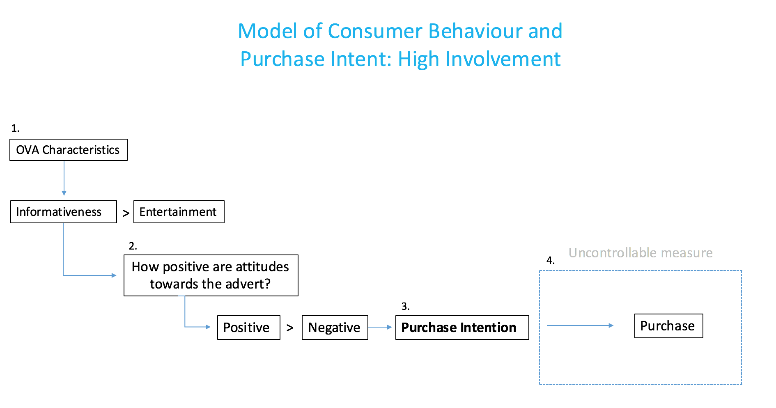

**Figure 19.** Framework for predicting purchase intent (Author: Atkinson 2016).

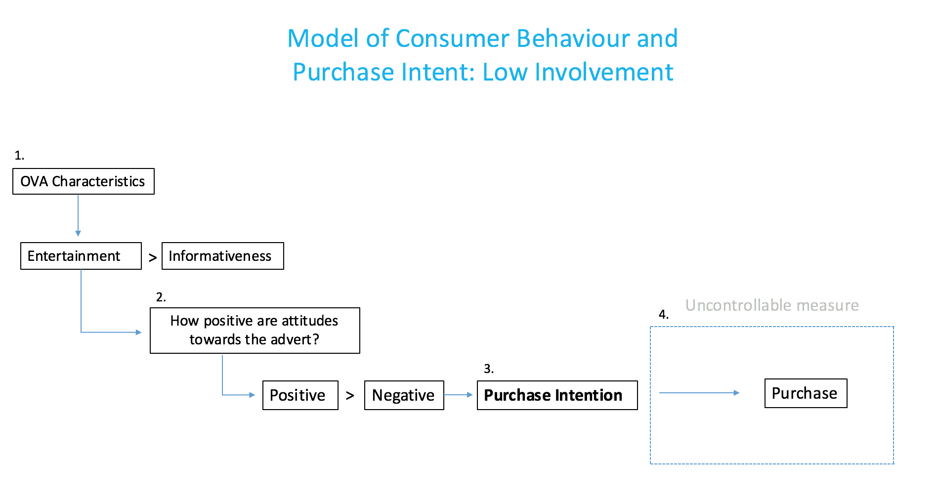

**Figure 20.** Framework for predicting purchase intent (Author: Atkinson 2016).



Click here to receive a sample

**Figure 21.** Driving purchase considerations with free trial and experimentation for high involvement beauty adverts.

**Figure 22.** Incorporate a call-to-action utilising location-based services inviting viewers to discover nearest store to sample product, providing personalised experience.



Find out where you can trial our latest products.